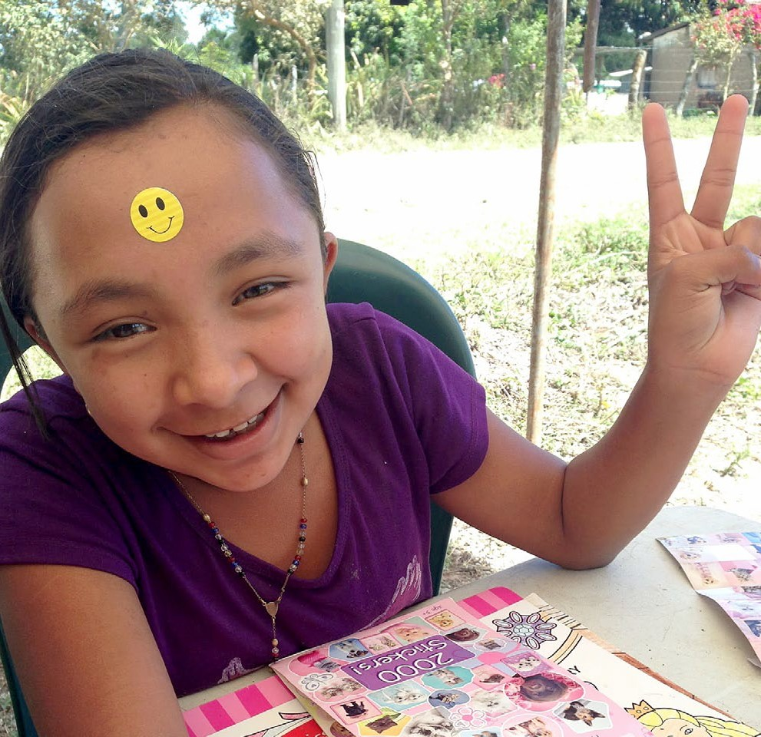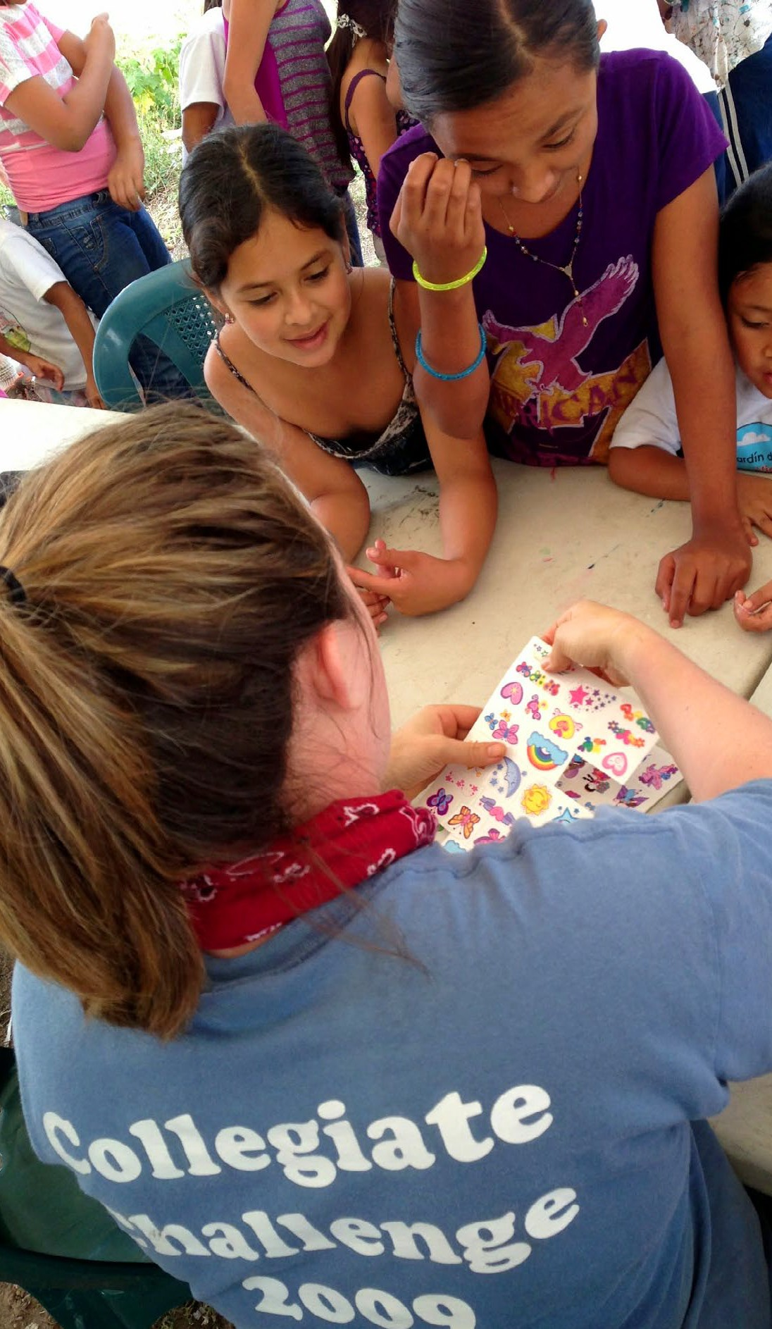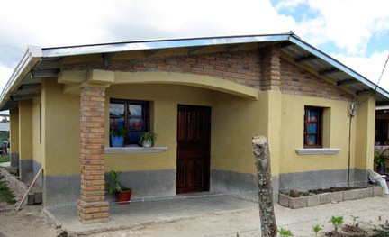2018 Habitat Mission Trips Santa Rosa de Copán, Honduras January 13–21 & March 3–11

Trip Cost
TRIP 1: January 13–21, 2018 #GVAxxxxx
Total Cost = Estimated $1800.00-$2300.00
$200 application fee (non-refundable) with application. First payment (50%) due November 13, 2017 with the remainder due no later than December 13, 2018.

TRIP 2: March 3–11, 2018 #GVAxxxxx
Total Cost = Estimated $1800.00-$2300.00
$200 application fee (non-refundable) with application. First payment (50%) due January 3, 2018 with the remainder due no later than February 3, 2018.
For more information and an application, visit www.habitatgreensboro.org/take-mission-trip

Or, contact Chris Tippens, ctippens@hhgg.org, (336) 707-8050, or Trip Leader, Gerard Davidson, gdavidson@wardblacklaw.com (336) 644-0424.

Join us for a Habitat Greensboro Mission Trip. You can make a difference.
2018 Habitat Mission Trips Santa Rosa de Copán, Honduras January 13–21 & March 3–11

Since 1991, Habitat Greensboro has supported the Habitat affiliate in Honduras through tithes and service. In January and March, 2018, we will again travel to Santa Rosa de Copán to partner with the volunteers and families in their ongo-
ing mission to eradicate poverty housing in their community. Visit our Mission Trip page at: www.habitat.org/where-we-build/honduras

View photos of previous Habitat Greensboro mission trips on www.Flickr.com and follow the team’s progress on Facebook and Twitter.

Habitat for Humanity of Greater Greensboro
603-B N. Elm Street, Greensboro, NC 27401 (336) 275-4663
2018 Habitat Mission Trips Santa Rosa de Copán, Honduras January 13–21 & March 3–11

2018 Habitat Mission Trips Santa Rosa de Copán, Honduras January 13-21 & March 3-11

Habitat mission trips are building trips.

While in Honduras, we work under the supervi- sion of Honduran masons, doing whatever tasks are needed.

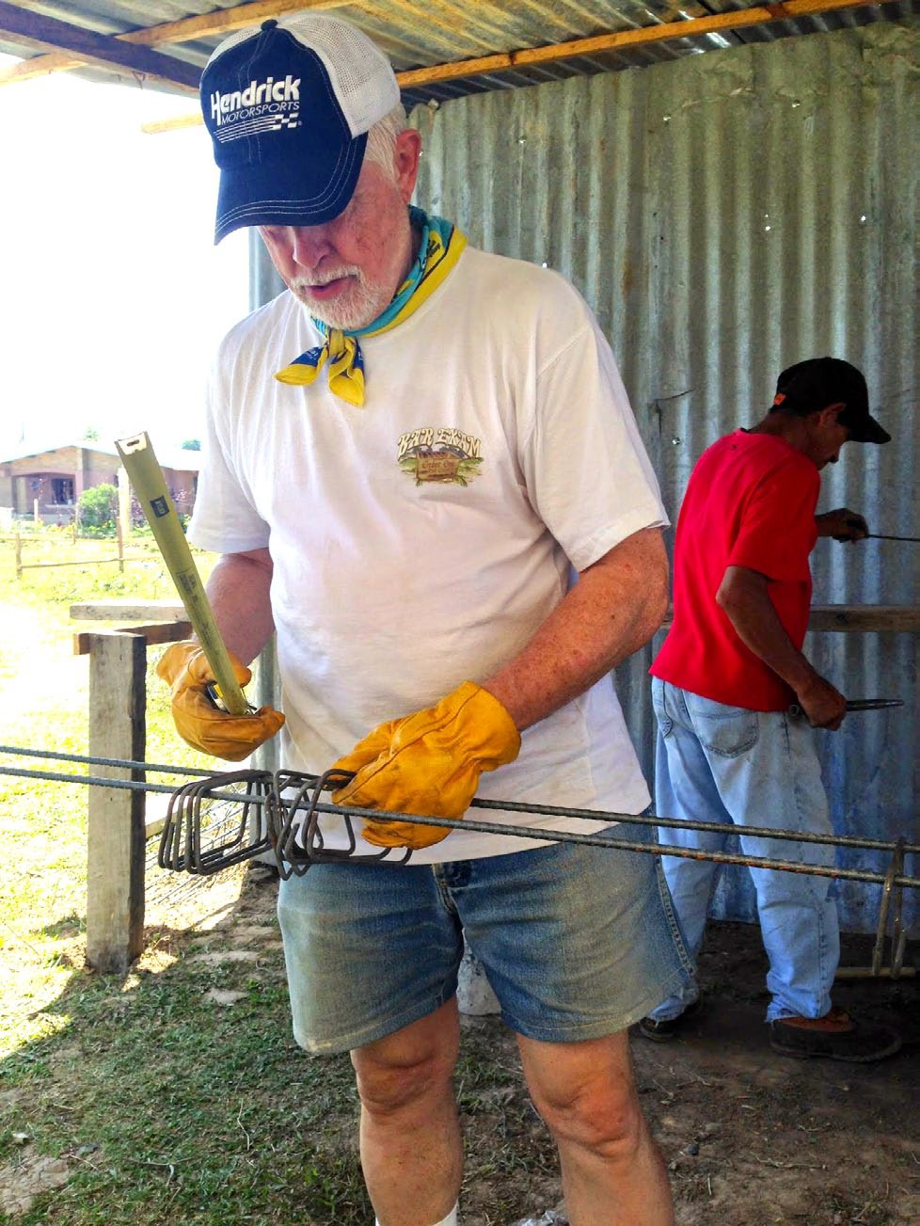

Common tasks
▪ Digging foundations
▪ Breaking up boulders (with sledge hammers)
▪ Moving rock and/or dirt
▪ Mixing mortar and cement (with shovels)
▪ Laying concrete blocks

Lighter tasks, including tying rebar and build- ing fences, are available for those unable to do heavier work.
The Honduran Experience
On the worksite, local children usually gather
once they discover that a friendly new group of Americans have arrived. The interaction with the children is an important and memorable part of our week.

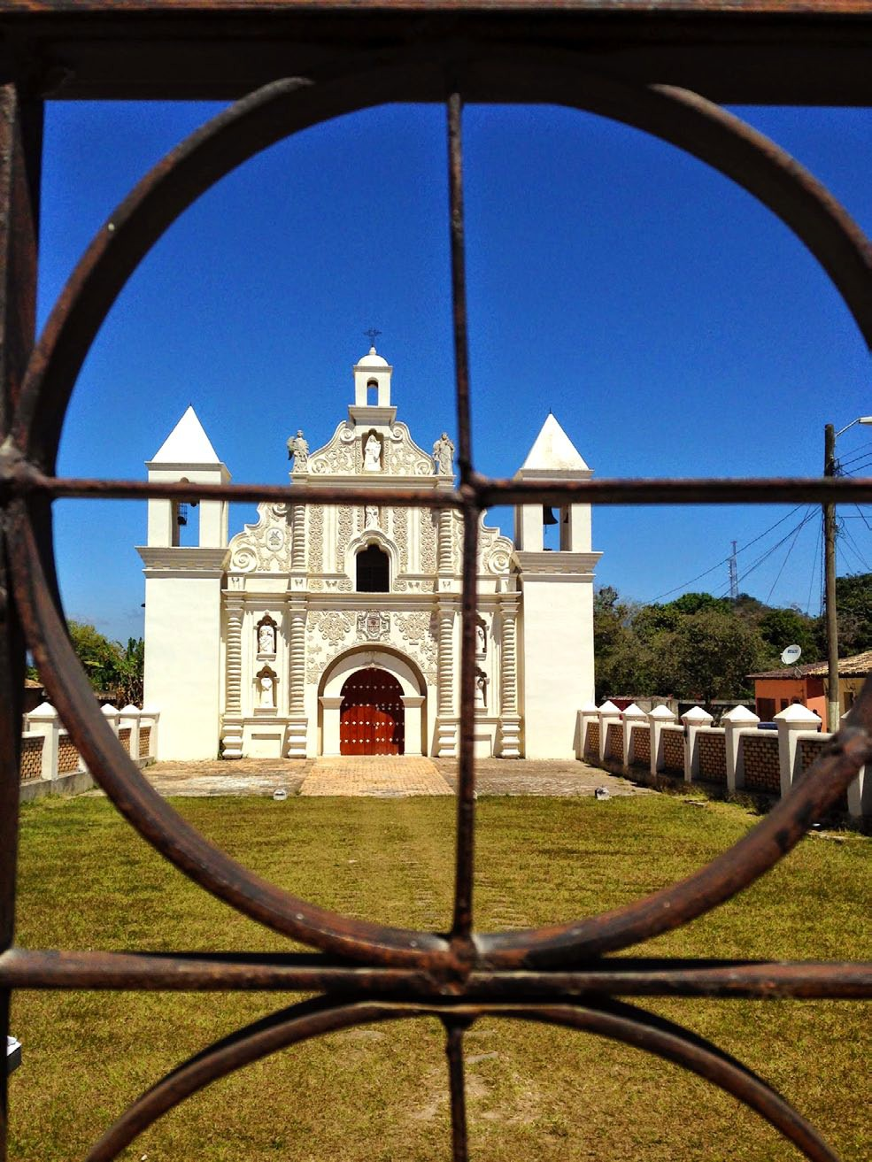

Participants should be at least 18 years of age (16, if accompanied by a parent or guardian), have a valid passport, and be physically capable to do the work. It is expected that participants support the mission of Habitat for Humanity—
Seeking to put God’s work into action, Habitat for Humanity brings people together to build homes, communities and hope.

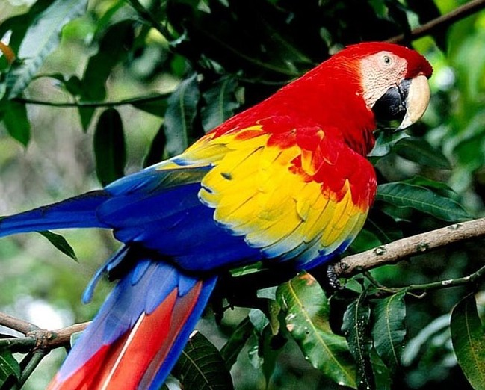

During the week, we will visit sites in and around Santa Rosa. At the end of the week, we spend a day as tourists, seeing historic sites and natural areas that our Habitat Honduras hosts think we would enjoy.

Accommodations
We will be staying at the Hotel San Jorge in
Santa Rosa de Copán, which will provide us with breakfast and lunch each day. At night we will eat dinner at local restaurants. All meals are included in the cost.

Immunization Requirements
Although there are no required immunizations,
the following are strongly recommended:

▪ Hepatitis A
▪ Hepatitis B (3-shot series)
▪ Typhoid
▪ Tetanus Booster (now comes combined with
Pertussis booster)
▪ Chloroquine – anti-malaria medication

There is malaria in Honduras, and it is YOUR DECISION whether or not to take Chloroquine. Check with your doctor.

